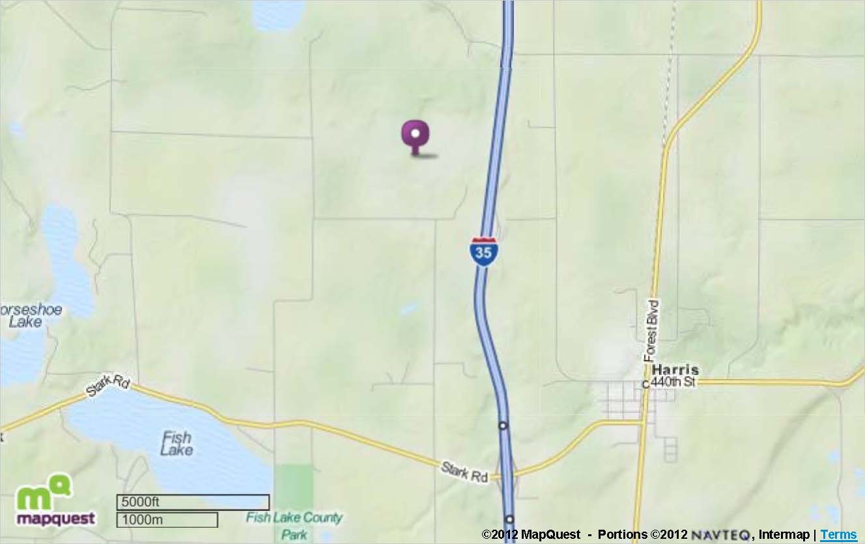
Gopher Rifle and Revolver Club

1. Take 35E or 35W to Forest Lake MN.
2. Drive 25 miles north on US 35 to exit 152 and take the Harris exit.
3. Exit 152 is CR10 or Stark Road. Make a left turn (West) on Stark Road.
4. Drive .5 miles to Falcon Ave. and turn right (North) on Falcon Ave.
5. Drive 1.5 miles on Falcon Ave. until it intersects with 450St.
6. Turn left (West) on 450St. And go .1 miles to the GRRC gate.

